***Software Engineering Tools Lab***

**Assignment no. 3**

Name: Sanket Shivaji Jadhav

PRN: 2020BTECS00005

Q.1. Create a project (give name of your project) in Jira, use template as Scrum and add your team members into this project.

*Ans:*

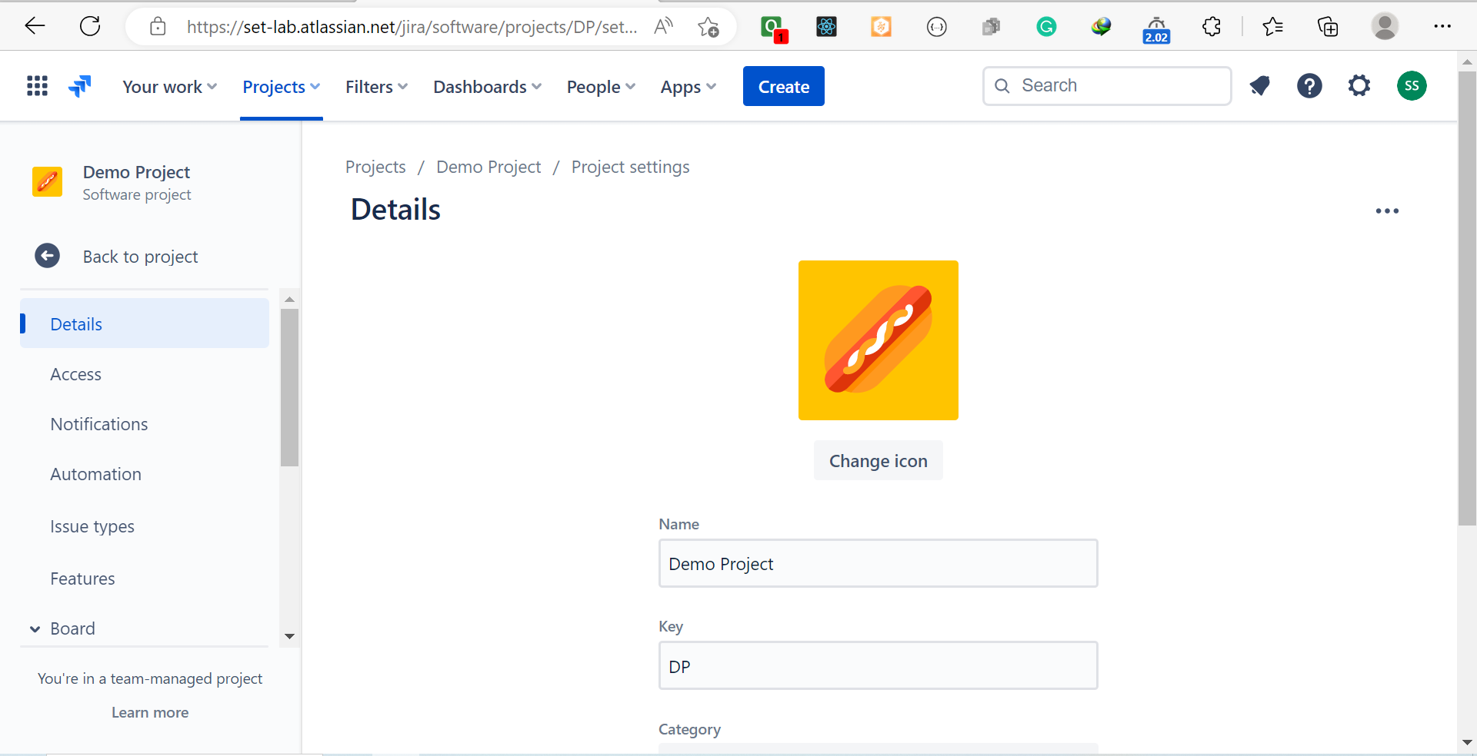

Q.2. Create an Epic into above project (main requirement of your project, e.g Creating a web application for student result generation).

*Ans:*

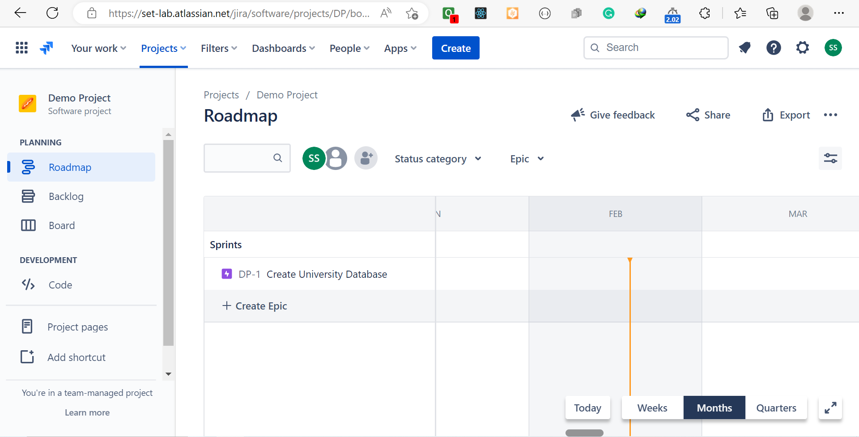

Q.3. Create at least 5 user stories with respect to above epic for your project.

*Ans:*

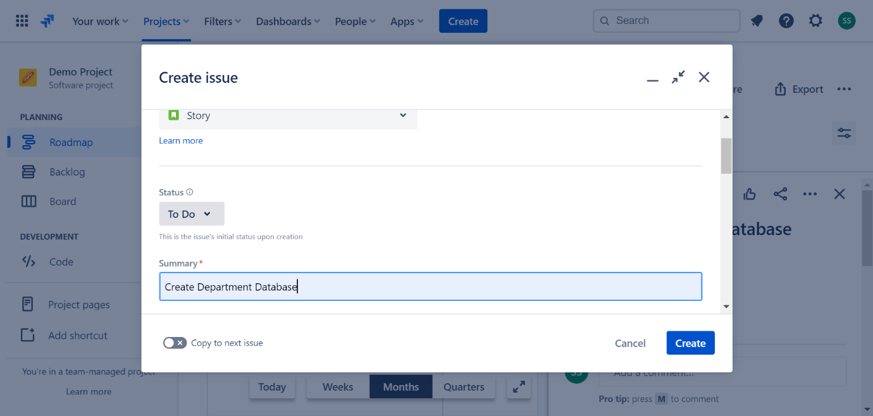

Q.4. Create at least 2 subtasks for every user story. Assign user stories to your team members.

*Ans:*

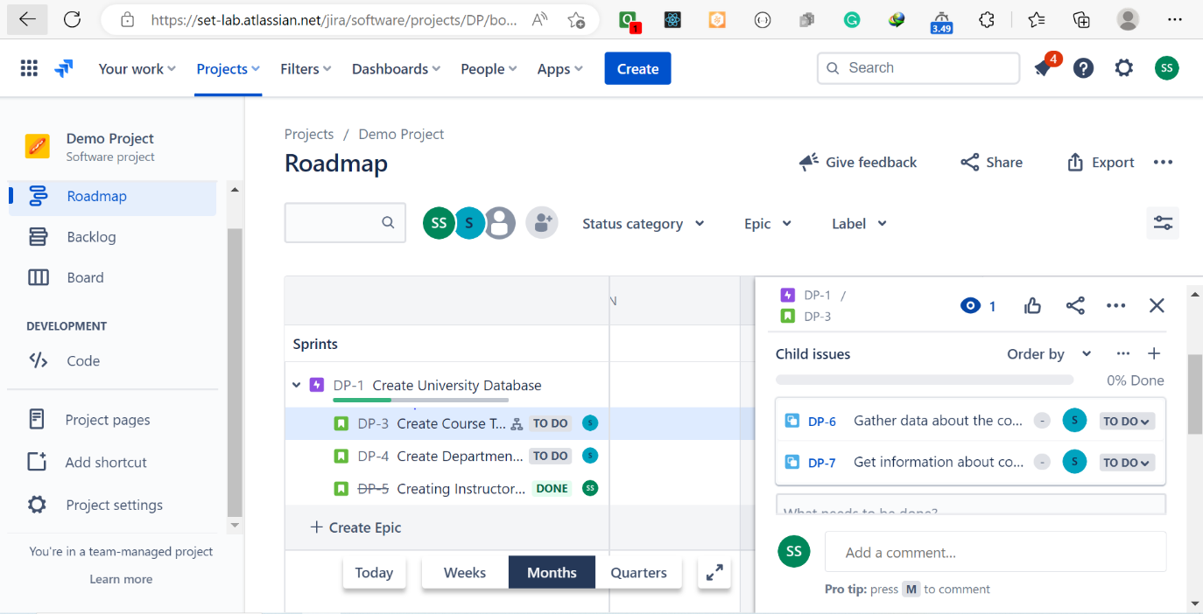

Q.5. Create sprints for every use stories and prioritize them according to your tasks. Assign time period for every user story.

*Ans:*

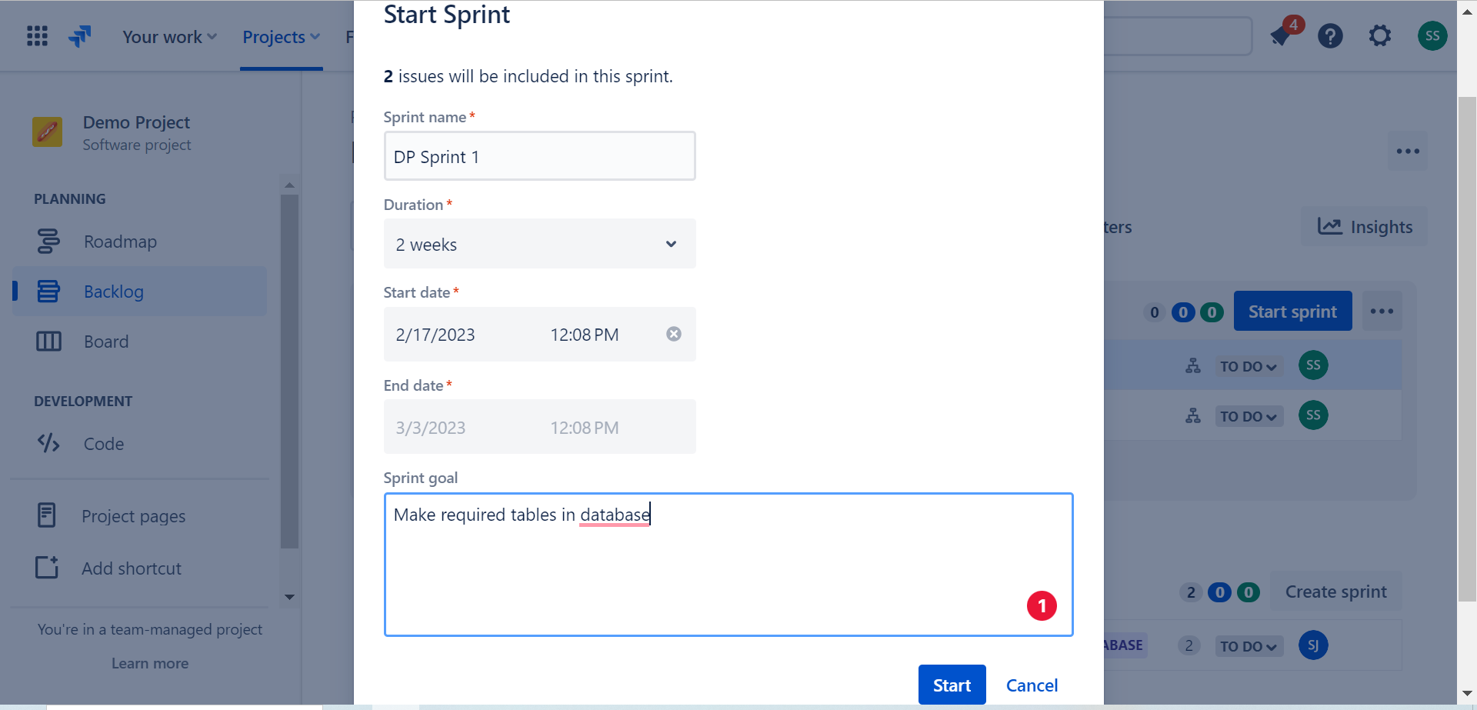

Q.6. Update the status of some user stories as To Do, In Progress or Completed according to sprints (add appropriate comments).

*Ans:*

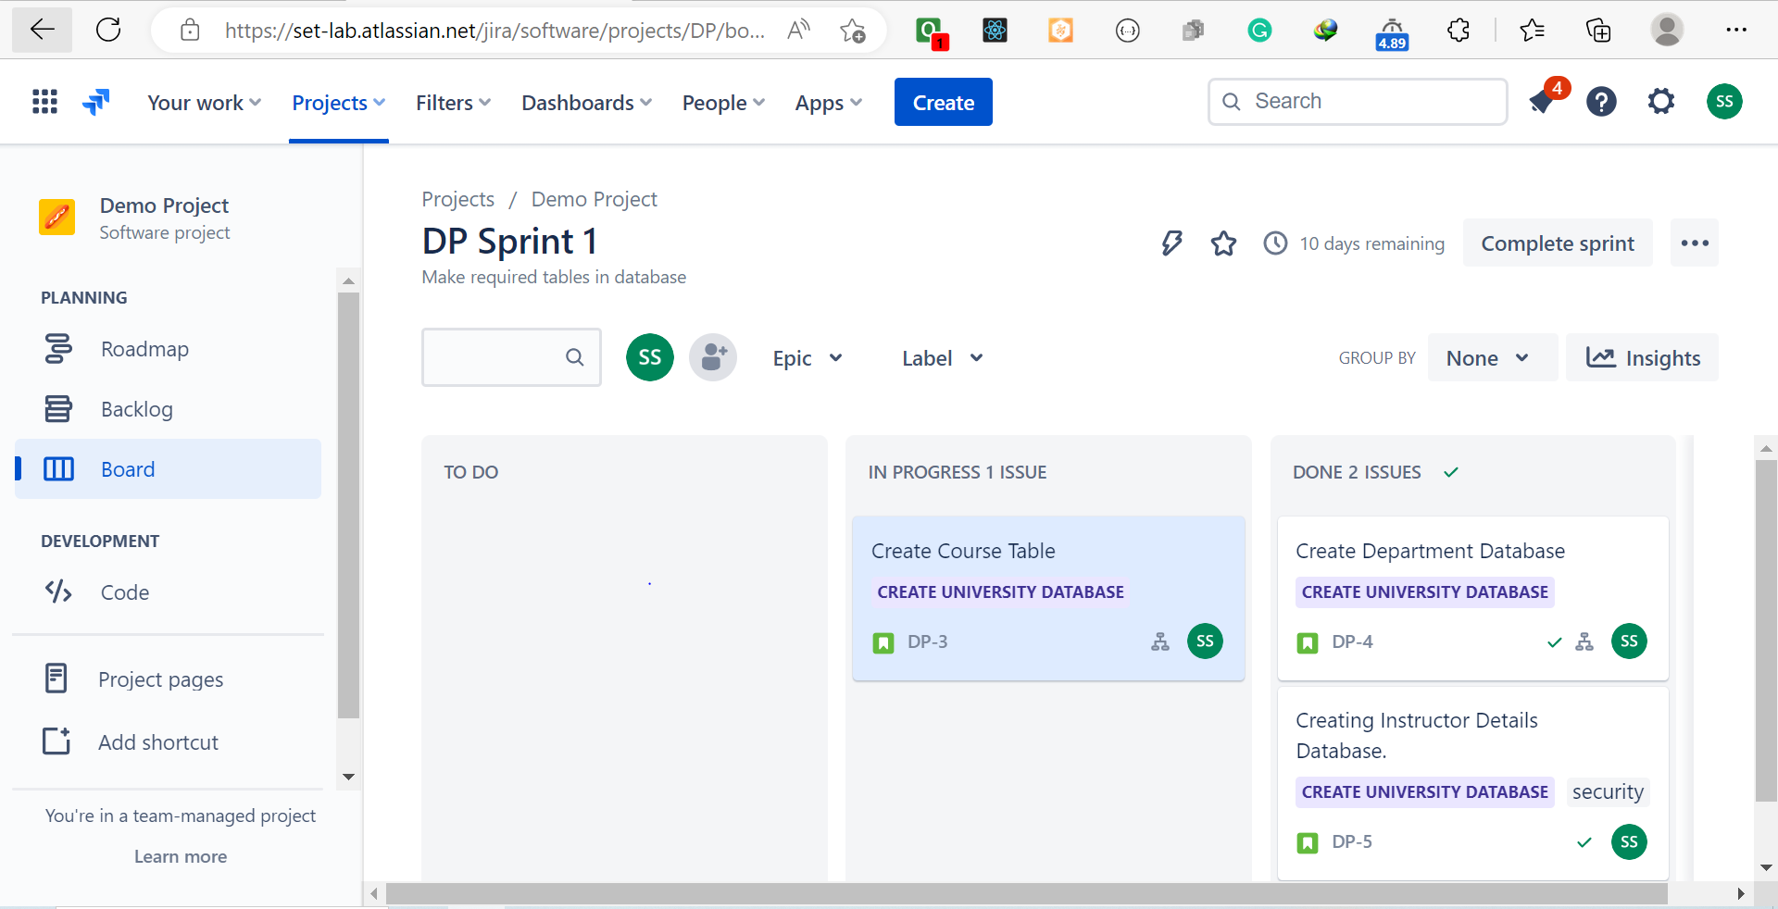

Q.7. Create a bug/issue for respective user story and epic and assign to respective member.

*Ans:*

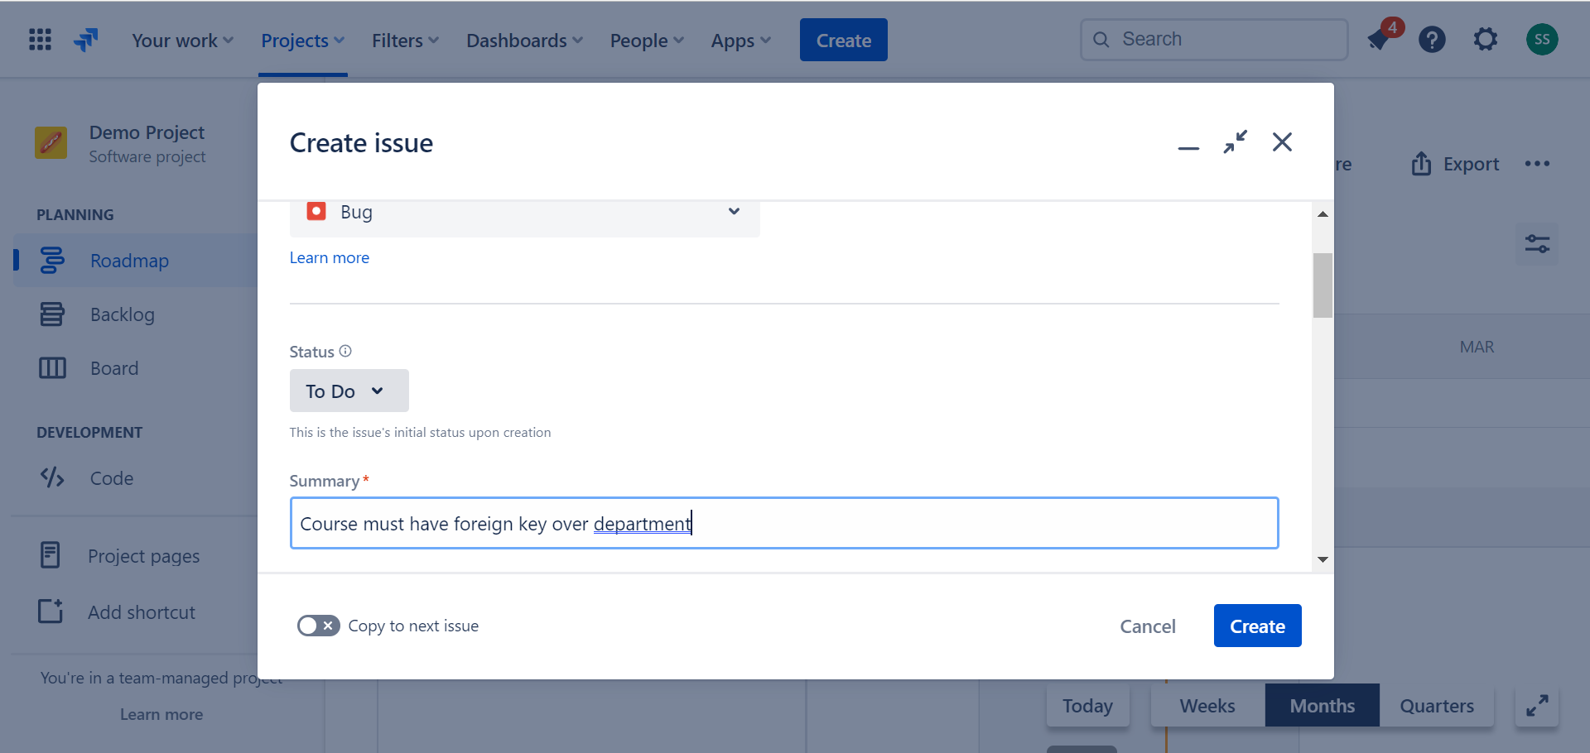

Q.8. Display reports (Burnup chart, Burndown chart) w.r.t your created project.

*Ans:*

Burnup Chart:

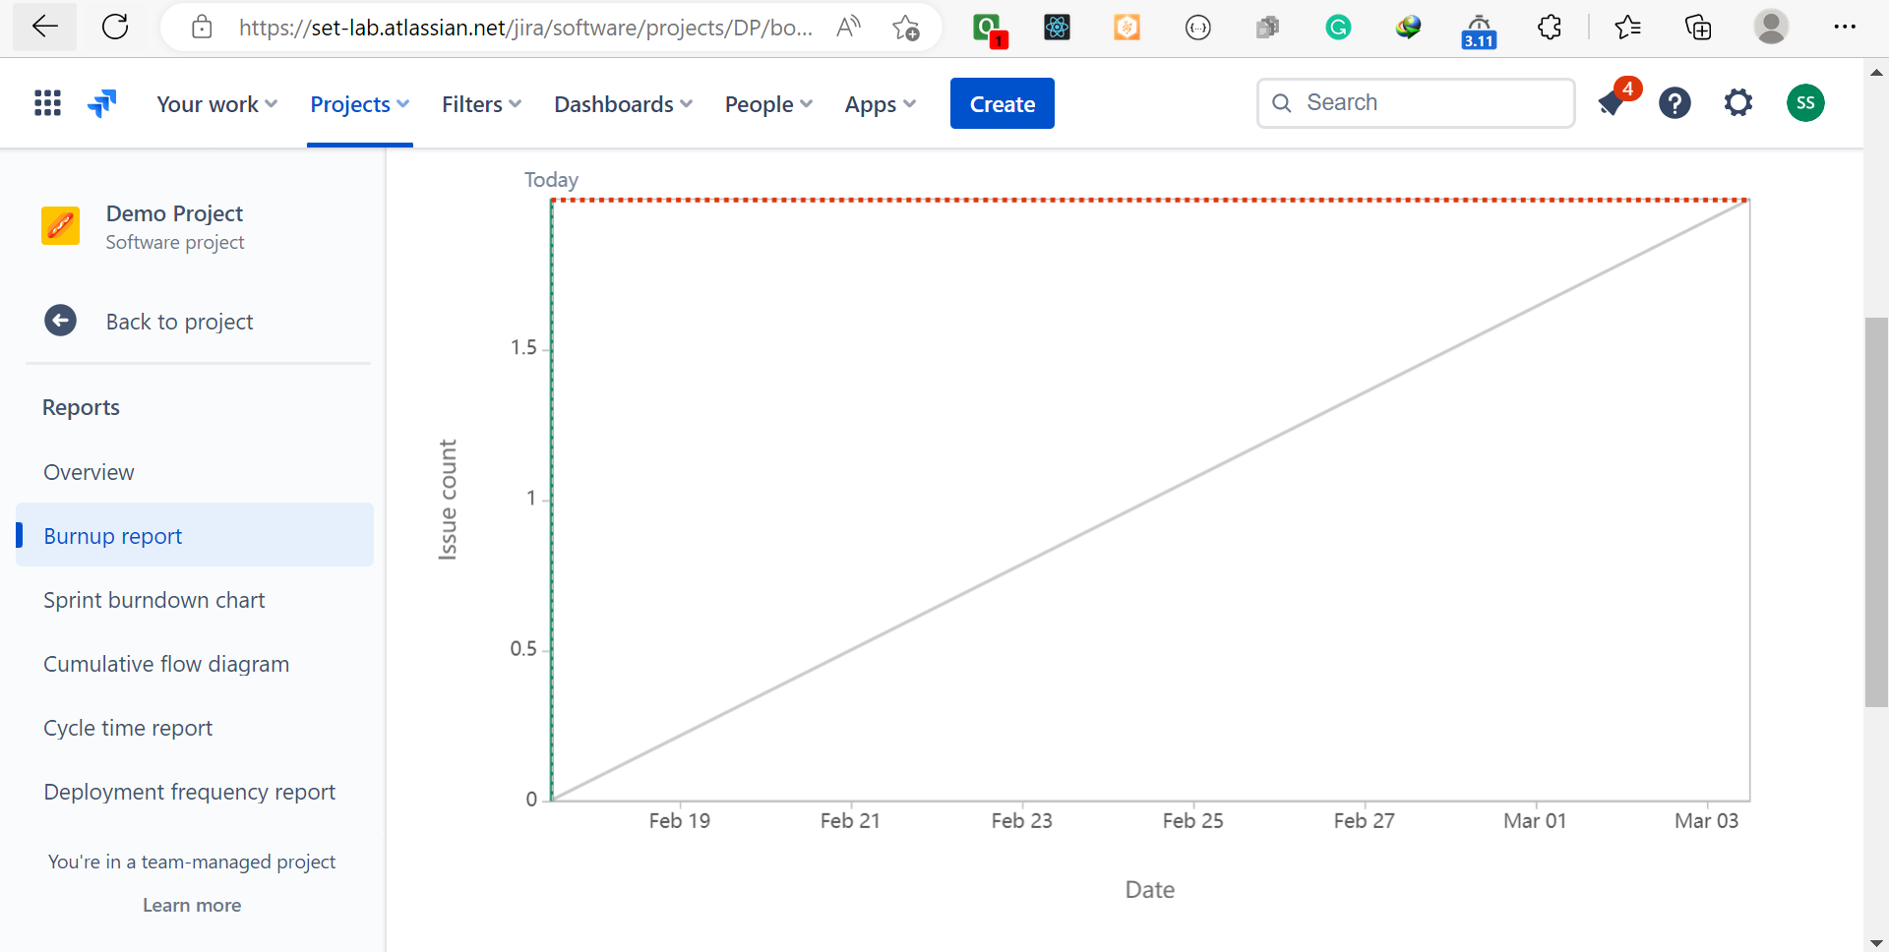

Burndown Chart:

